**PRACTICAL 7**

**AIM:**

Create simple application using Hyperledger playground.

**PRACTICAL:**

**Step One: Open the Hyperledger Composer Playground**

Open Composer Playground. You should see the My Business Network screen. The My Business Network page shows you a summary of the business networks you can connect to, and the identities you can use to connect to them.

**Step Two: Creating a new business network**

We want to create a new business network from scratch. A business network has a couple of defining properties; a name, and an optional description. You can also choose to base a new business network on an existing template, or import your own template.

1. Click Deploy a new business network under the Web Browser heading to get started.
2. The new business network needs a name, let's call it tutorial-network.
3. Optionally, you can enter a description for your business network.
4. Next we must select a business network to base ours on, because we want to build the network from scratch, click empty-business-network.
5. Now that our network is defined, click Deploy.

**Step Three: Connecting to the business network**

Now that we've created and deployed the business network, you should see a new business network card called admin for our business network tutorial-network in your wallet. The wallet can contain business network cards to connect to multiple deployed business networks.

When connecting to an external blockchain, business network cards represent everything necessary to connect to a business network. They include connection details, authentication material, and metadata.

To connect to our business network click Connect now under our business network card.

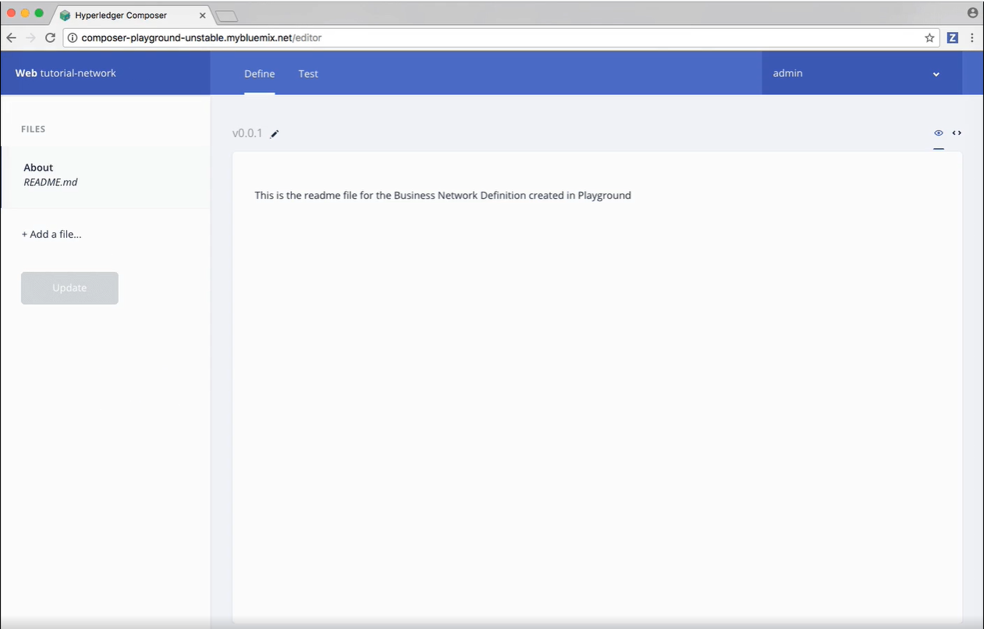

**Step Four: Adding a model file**

As you can see, we're in the Define tab right now, this tab is where you create and edit the files that make up a business network definition, before deploying them and testing them using the Test tab.

As we selected an empty business network template, we need to define our business network files. The first step is to add a model file. Model files define the assets, participants, transactions, and events in our business network.

1. Click the Add a file button.
2. Click the Model file and click Add.
3. Delete the lines of code in the model file and replace it with this:

/**

 * My commodity trading network

 */

namespace org.acme.mynetwork

asset Commodity identified by tradingSymbol {

    o String tradingSymbol

    o String description

    o String mainExchange

    o Double quantity

    --> Trader owner

}

participant Trader identified by tradeId {

    o String tradeId

    o String firstName

    o String lastName

}

transaction Trade {

    --> Commodity commodity

    --> Trader newOwner

}

**Step Five: Adding a transaction processor script file**

Now that the domain model has been defined, we can define the transaction logic for the business network. Composer expresses the logic for a business network using JavaScript functions. These functions are automatically executed when a transaction is submitted for processing.

1. Click the Add a file button.
2. Click the Script file and click Add.
3. Delete the lines of code in the script file and replace it with the following code:

/**

 * Track the trade of a commodity from one trader to another

 * @param {org.acme.mynetwork.Trade} trade - the trade to be processed

 * @transaction

 */

function tradeCommodity(trade) {

    trade.commodity.owner = trade.newOwner;

    return getAssetRegistry('org.acme.mynetwork.Commodity')

        .then(function (assetRegistry) {

            return assetRegistry.update(trade.commodity);

        });

}

**Step Six: Access control**

Access control files define the access control rules for business networks. Our network is simple, so the default access control file doesn't need editing. The basic file gives the current participant networkAdmin full access to business network and system-level operations.

While you can have multiple model or script files, you can only have one access control file in any business network.

**Step Seven: Deploying the updated business network**

Now that we have model, script, and access control files, we need to deploy and test our business network.

Click Update to deploy the changes to our business network.

**Step Eight: Testing the business network definition**

Next, we need to test our business network by creating some participants (in this case Traders), creating an asset (a Commodity), and then using our Trade transaction to change the ownership of the Commodity.

Click the Test tab to get started.

**Step Nine: Creating participants**

The first thing we should add to our business network is two participants.

1. Ensure that you have the Trader tab selected on the left, and click Create New Participant in the upper right.
2. What you can see is the data structure of a Trader participant. We want some easily recognizable data, so delete the code that's there and paste the following:

{

  "$class": "org.acme.mynetwork.Trader",

  "tradeId": "TRADER1",

  "firstName": "Jenny",

  "lastName": "Jones"

}

1. Click Create New to create the participant.
2. You should be able to see the new Trader participant you've created. We need another Trader to test our Trade transaction though, so create another Trader, but this time, use the following data:

{

  "$class": "org.acme.mynetwork.Trader",

  "tradeId": "TRADER2",

  "firstName": "Amy",

  "lastName": "Williams"

}

Make sure that both participants exist in the Trader view before moving on!

**Step Ten: Creating an asset**

Now that we have two Trader participants, we need something for them to trade. Creating an asset is very similar to creating a participant. The Commodity we're creating will have an owner property indicating that it belongs to the Trader with the tradeId of TRADER1.

1. Click the Commodity tab under Assets and click Create New Asset.
2. Delete the asset data and replace it with the following:

{

  "$class": "org.acme.mynetwork.Commodity",

  "tradingSymbol": "ABC",

  "description": "Test commodity",

  "mainExchange": "Euronext",

  "quantity": 72.297,

  "owner": "resource:org.acme.mynetwork.Trader#TRADER1"

}

1. After creating this asset, you should be able to see it in the Commodity tab.

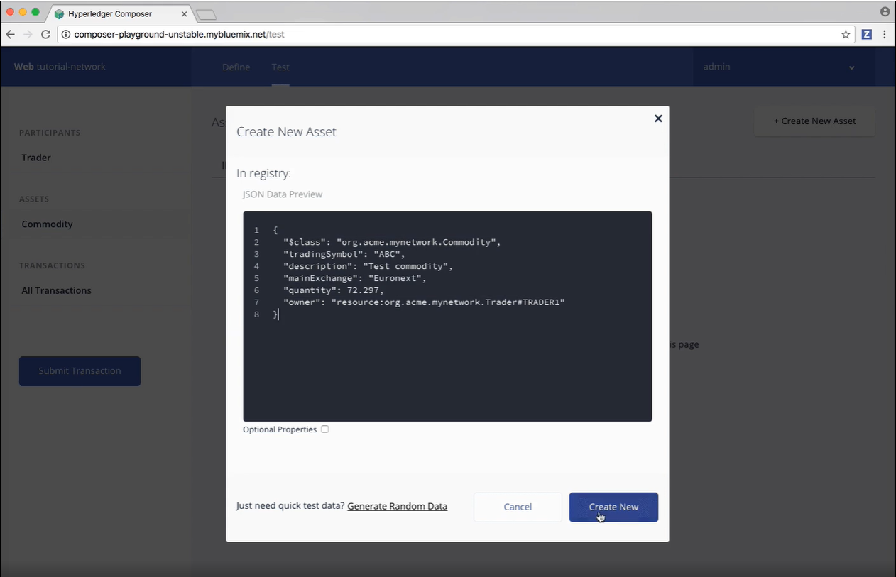

**Step Eleven: Transferring the commodity between the participants**

Now that we have two Traders and a Commodity to trade between them, we can test our Trade transaction.

Transactions are the basis of all change in a Hyperledger Composer business network, if you want to experiment with your own after this tutorial, try creating another business network from the My Business Network screen and using a more advanced business network template.

To test the Trade transaction:

1. Click the Submit Transaction button on the left.
2. Ensure that the transaction type is Trade.
3. Replace the transaction data with the following, or just change the details:

{

  "$class": "org.acme.mynetwork.Trade",

  "commodity": "resource:org.acme.mynetwork.Commodity#ABC",

  "newOwner": "resource:org.acme.mynetwork.Trader#TRADER2"

}

1. Click Submit.
2. Check that our asset has changed ownership from TRADER1 to TRADER2, by expanding the data section for the asset. You should see that the owner is listed as resource:org.acme.mynetwork.Trader#TRADER2.
3. To view the full transaction history of our business network, click All Transactions on the left. Here is a list of each transaction as they were submitted. You can see that certain actions we performed using the UI, like creating the Trader participants and the Commodity asset, are recorded as transactions, even though they're not defined as transactions in our business network model. These transactions are known as 'System Transactions' and are common to all business networks, and defined in the Hyperledger Composer Runtime.

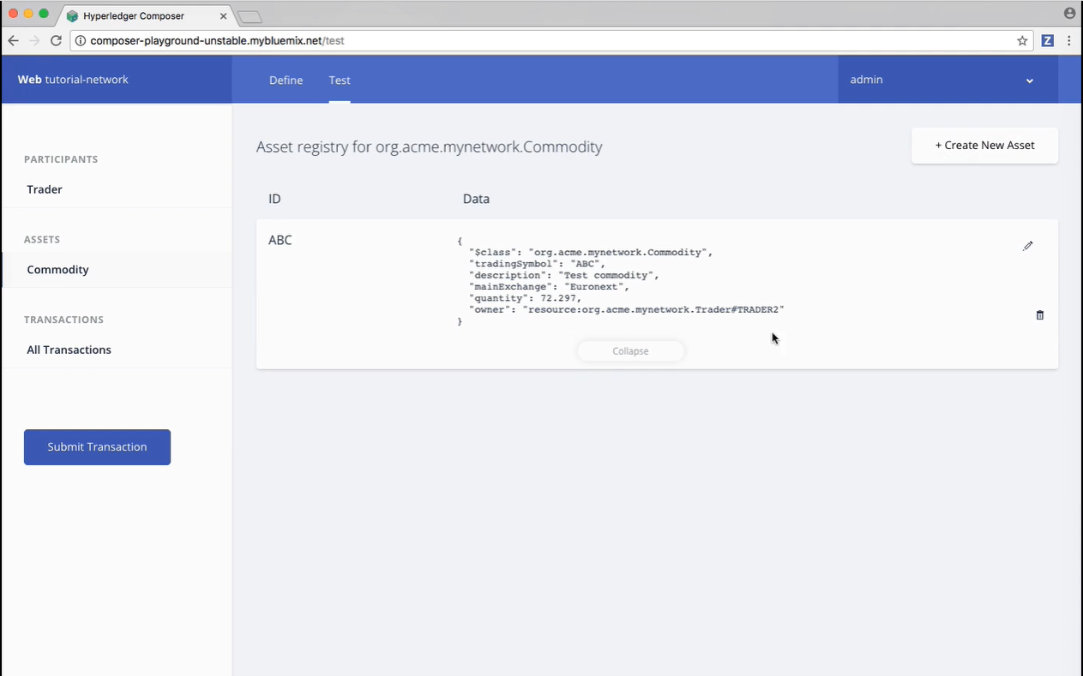

**Logging out of the business network**

Now that transactions have successfully run, we should log out of the business network, ending up at the My Business Network screen where we started.

In the upper-right of the screen is a button labelled admin. This lists your current identity, to log out, click admin to open the dropdown menu, and click My Business Networks.

**CONCLUSION:**

In this practical, we completed the initial Hyperledger Composer Playground tutorial. We walked through setting up a business network, defining our assets, participants and transactions, and testing our network by creating some participants and an asset, and submitting transactions to change the ownership of the asset from one to another.